Weyland at a Glance
Annual Report 2025 – chapter 2
Noah Fischer · 26 February 2026
 | 2025 | 2024
Operating capacity | 1.1 GW | 1.03 GW
Generation | 2,860 GWh | 2,664 GWh
Revenue | EUR 312 m | EUR 276 m
EBITDA | EUR 148 m | EUR 126 m
CO₂ avoided | 1.2 Mt | 1.08 Mt
Employees | 450 | 418
Pipeline | 4.2 GW | 3.6 GW

Weyland Energy develops, builds and operates wind, solar and storage assets in Germany, the United Kingdom and Denmark. Founded in Hamburg in 2011, we have offices in Hamburg, Edinburgh and Copenhagen.
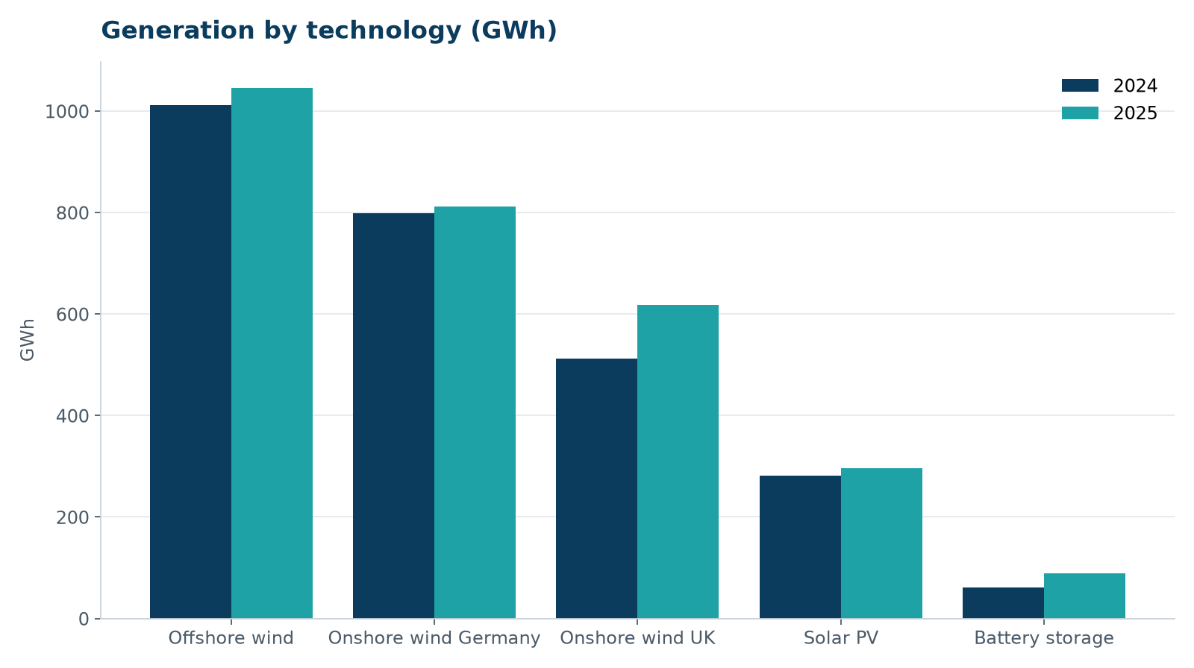
Generation by technology 2024 and 2025

Milestones 2025
- 2 April – Annual Report 2024 published
- 30 June – turbine supply agreement with Halden Turbine Systems for Harrow Bay
- 1 October – Dr. Amara Okafor becomes CEO
- 18 November – Millbrook land lease signed
- December – Harrow Bay term sheet agreed with Hanseatic Infrastructure Bank

